**LEBANESE AMERICAN UNIVERSITY**

**USAID – HIGHER EDUCATION SCHOLARSHIP PROGRAM**

**HES - Volunteering Program Verification Form**

This form is to be used to document volunteering hours. If a student volunteers for multiple organizations, a separate form must be used for each organization. **This form must be turned in by the 28th of each month, the latest.**

I certify that the scholar Waed Maddah completed a total of 1 hours of service at InnovaThrive.

The hours were completed hours as per the below:

Hours # 0 (date) _2/12 – 6/12_ (initials of supervisor) __A.K.___

Hours # 0 (date) _9/12 – 13/12_ (initials of supervisor) __A.K.___

Hours # 0 date) _16/12 – 20/12 (initials of supervisor) __A.K.___

Hours # 1 date) _23/12 - 27/12 (initials of supervisor) __A.K.___

Brief description of the activities the scholar performed or participated in:

Conducting thorough research and delivering the necessary information in a comprehensive and detailed mannerWritten

Written feedback about the scholar’s performance:

Waed Maddah has demonstrated the ability to conduct thorough research and deliver comprehensive, detailed information effectively. However, the volunteering form was submitted late, which is unacceptable. Adhering to deadlines is crucial to ensure the smooth progression of tasks and maintain overall efficiency. It is essential to improve in this area to avoid delays in the future.

Please rate the overall performance of the scholar at your organization:

|  |  |  |  |
| --- | --- | --- | --- |
|  | Mastery (5) | Proficient (3) | Emerging (1) |
| **Problem solver** | X |  |  |
| **Engaged & Committed** | X |  |  |
| **Open-minded & multicultural** | X |  |  |

Signature

& stamp

__________________________

_

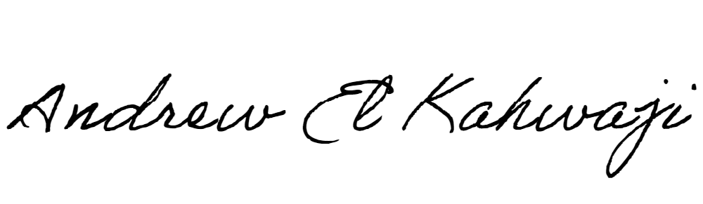

Printed Name _Andrew El Kahwaji_

Date __26/12/2024___

Email __andrew.lifesculptor.coo@gmail.com __

Phone __+961 71 914 378__